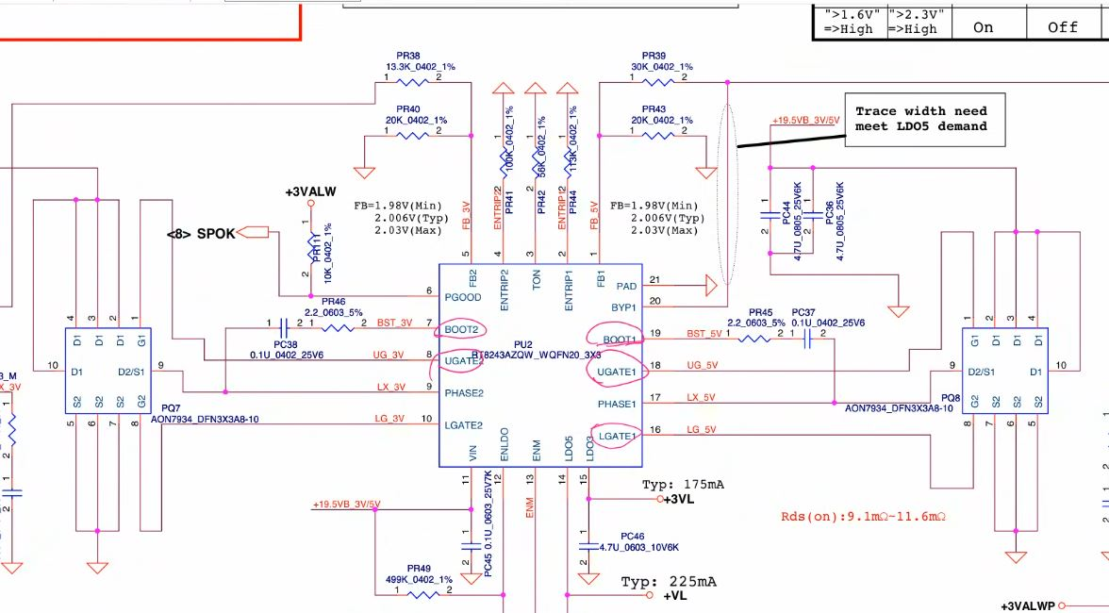

- VCC 19 v
- ENLDO By voltage devider
- LDO3, LDO5 – 3VL OUTPUT
- ENM (enable master from SIO)
- ENTRIP1, ENTRIP2
- BOOT1, BOOT2
- UGATE1, UGATE2
- LGATE1(should be low hight(3,4, 5 hoga to switching start nhi hoga)), LGATE2
- PHASE1(mosfet output voltage feedback), BOOT1, UGATE, LGATE – internal process
- FB1
- PGOOD

